Project 1 Design Document

Main Page window:

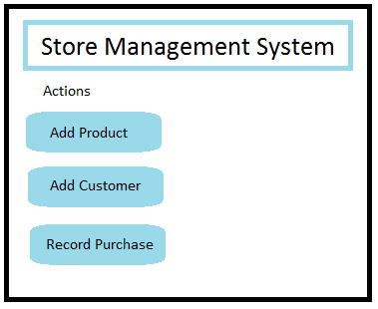

From main page, be able to navigate to Add Product, Add Customer, or Record Purchase windows.

Add Product window:

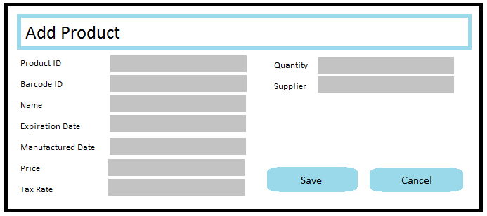

Once appropriate fields are filled out with valid data, when save is selected, display a message dialogue to user to notify save was successful.

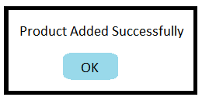

Alternatively, if user clicks Cancel button, Add Product window should close and return user back to main program window.

Exception Case: if a product that already exists is added to the database, the system returns an open dialogue that warns the user of the error.

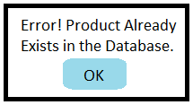

Add Customer window:

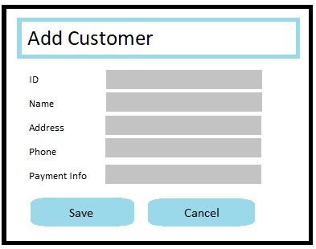

Once appropriate fields are filled out with valid data, when save is selected, display a message dialogue to user to notify customer was added successfully.

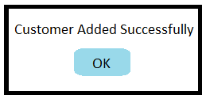

Alternatively, if user clicks Cancel button, Add Customer window should close and return user back to main program window.

Exception Case: if a customer that already exists is added to the database, the system returns an open dialogue that warns the user of the error.

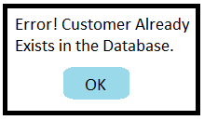

Record Purchase window:

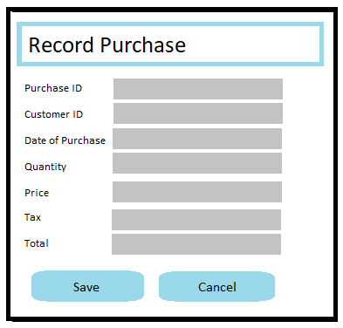

Once appropriate fields are filled out with valid data, when save is selected, display a message dialogue to user to notify that the purchase was recorded successfully.

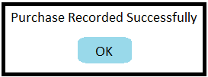

Alternatively, if user clicks Cancel button, Record Purchase window should close and return user back to main program window.

Exception Case: if a purchase that already exists is added to the database, the system returns an open dialogue that warns the user of the error.

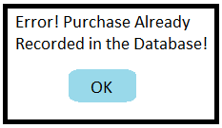

Database Relations Design

